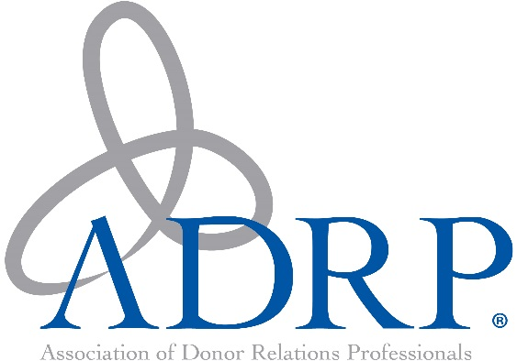

**THE ASSOCIATION OF DONOR RELATIONS PROFESSIONALS**

**VOLUNTEER SERVICE AWARD**  
is hereby presented to

**Mary Weingartner**

Mary Weingartner, Director of Donor Relations at University of Chicago, we honor you as the 2017 recipient of the Association of Donor Relations Professionals Volunteer Service Award.

*“You have done more than lead, you have inspired.” –Dan Zadra*

Mary, you are an exemplary ADRP member who has made the most out of your volunteer experience. From ADRP’s International Conference, to the Hub newsletter, to the Midwest Regional, you have given so much of yourself to the ADRP mission, bringing joy, gratitude and grace to all your interactions with members of the donor relations community.

You first volunteered your time as a presenter at the 2011 International Conference in San Francisco. This quickly blossomed into Content co-chair for the 2012 International Conference and Marketing co-chair for the 2017 International Conference. We are incredibly grateful that you will bring your passion for quality professional development to your role as Conference Chair for the 2018 International Conference in

St. Louis.

As a key member of the team who launched the Midwest Regional, you played a pivotal role in helping to grow this event from a breakfast panel to a full day of educational sessions with more than 100 attendees. Your desire to ensure attendees have meaningful opportunities to engage with each other has built a strong network of donor relations professionals, who can learn and grow together in the Midwest region.

Your volunteer leadership encompasses so many facets. You also serve on the Hub’s editorial board, ensuring that each month our members receive up-to-date information from the field and insights into best practices.

In recognition of the heart and soul that you bring to all your ADRP volunteer efforts, we are proud to present you with the 2017 Association of Donor Relations Professionals Volunteer Service Award.

Congratulations!

With sincere gratitude,

Kathleen Diemer, President September 2017